Methodology and Protocol to Assess Greenhouse Gas Emissions from Onsite Sanitation in LOW- AND MIDDLE-INCOME countries

BACKGROUND
Greenhouse Gas (GHG) emissions are the main drivers of climate change, with the IPCC calling for priority action on methane (CH₄). Sanitation is a plausible source of significant GHG emissions but has been neglected from both a research and policy point of view. Only 2% of Nationally Determined Contributions (NDCs) include sanitation or do not consider it in detail (Dickin et al., 2020). With respect to onsite sanitation (i.e., septic tanks and pit latrines), it has been estimated that approximately 1% of total global CH₄ emissions come from pit latrines alone (Reid et al., 2014). Onsite sanitation systems tend to harbour moist, anaerobic, high nutrient environments, and produce significant amounts of GHG emissions (Ryals et al., 2019), with the main GHG emissions associated with them being carbon dioxide (CO₂), CH₄, and nitrous oxide (N₂O) (Diaz-Valbuena et al., 2011; Reid et al., 2014; Ryals et al., 2019; Huynh et al., 2021).
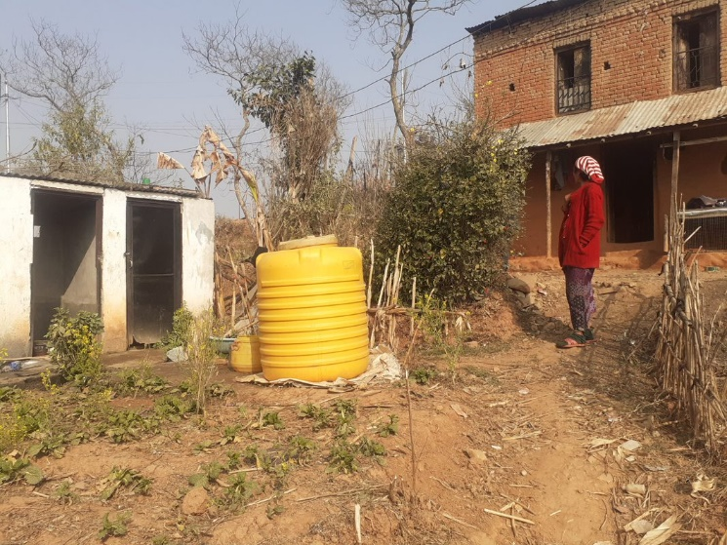
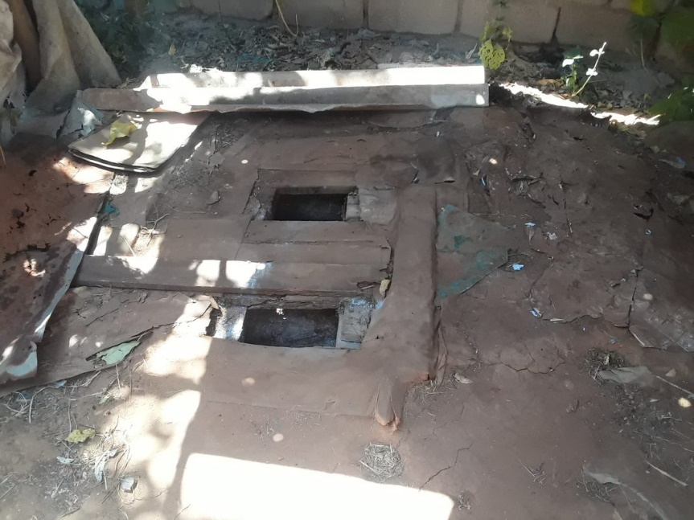
In 2015 in sub-Saharan Africa, Central and South Asia and Oceania, on-site system users exceed sewer connections in urban areas (JMP 2017). Figures from 2020 show that globally, people were more likely to use onsite sanitation technologies rather than sewerage connections, for the first time since reporting began (WHO and UNICEF, 2021). This drive has been attributed to the uptake in sanitation systems in rural areas which is often in the form of on-site solutions. Due to the increase of pit latrines across the African continent, and campaigning in South Asian Countries pushing to be “Open Defecation Free”, an increase in future GHG emissions is predicted. It is interesting to note that Reid et al. (2014) documents a small decline in GHG emissions between 2000 and 2015 due to China investing in centralised sanitation systems.
Figure 1: Left: Septic tank site in Nepal. Right: Pit latrine site in Ethiopia.

IMPORTANCE
Understanding the quantity of GHG emissions which can be attributed to onsite sanitation systems, and how these may vary with alternative design and management strategies, is important, in light of the growing number of such systems now being installed in low and middle-income countries (LMICs). In many countries, a range of unlined, lined and sealed pits and tanks (often broadly described as ‘pit latrines’, or ‘septic tanks’) are now widely promoted (JMP, 2021). Scientific studies have shown that all types of containments seem to emit a considerable amount of GHGs (Reid et al., 2014; Ryals et al., 2019; Huynh et al., 2021), but many of these studies have been carried out in ‘idealised’ laboratory conditions or on well -built systems in high-income countries (HICs) contexts which differ greatly to the conditions in practice in LMICs.
Current estimates of GHG emissions from on-site sanitation are unreliable. An improved set of empirical measurements taken from actual systems as installed in the field, will provide a basis for better assessments of emissions at the local and national levels. This could enable government, and funding agencies to make better decisions on investment, design, and management of sanitation, including to make informed technology and management choices to help reduce GHG emissions. More reliable and granular data will also help represent the baseline emission situation, and to track the Nationally Determined Contributions (NDCs) for reducing sectoral emissions.

CURRENT GAPS AND CHALLENGES
Current estimates rely heavily on several assumptions, based on theoretical production of methane from biological oxygen demand (BOD) and N₂O emissions from total nitrates (TN). Even so, the findings clearly represent a significant segment of potential emissions, enough to warrant closer study. One challenge in building the empirical basis for this work is the lack of a standard, practical methodology for gathering GHG emission data from onsite sanitation systems. Since there is not an accepted empirical method, results are not easy to be considered in larger suggested methodologies, such as that presented by the IPCC. Therefore, the data in the IPCC is skewed to other types of systems.
There are many challenges when measuring GHG emissions from sanitation systems in-field in LMICs. Most methods for measuring GHG emissions are based on laboratory measurements of samples collected in the field. To the best of our knowledge, there is not yet an approach to collection of gas from sanitation facilities in-field which could be applied to the diverse types of facilities and difficult access. found in LMICs. The designs of flux chambers which are currently used are not simple to build in LMICs and are often unsuited to the conditions found it field. Gas sample analysis is challenging in general but made more challenging in the context of concern, as the number of laboratories capable of this analysis are often limited to the capital city in LMICs. When travel time is significant, the costs associated with storage, transport, and time, all increase. This in turn may skew observations towards more accessible sites, which may not be representative. The alternative is to make direct observations on site. However, current literature does not offer an approach that could be applied to actual latrines as we find them in the field.
Additionally, there is uncertainty around the specific impacts of climate change. The intensity and unpredictability of weather patterns are set to increase, but exactly how is undetermined. These factors, such as temperature and rainfall, can have a significant impact on the GHGs from sanitation systems –posing additional challenges. Local environmental conditions, containment types, and socio-economic settings may also affect emissions from onsite sanitation systems (note: we are only considering the interface [toilet] and containment, not the treatment).

THE SCARE PROJECT
The “Sanitation and Climate: Assessing Resilience and Emissions” (SCARE) Project, is a collaboration between University of Bristol, University of Leeds, University of Technology Sydney (Australia), Kathmandu University (Nepal), Haramaya University (Ethiopia), Kyambogo University (Uganda) and the Global Green growth Institute. It is funded by the Bill and Melinda Gates Foundation. Undertaking field work in Ethiopia, Uganda, Nepal, and Senegal, the SCARE Project has four key objectives:

- To provide improved estimates of GHG emissions associated with the sanitation chain in urban areas and small towns with a primary focus on onsite sanitation.
- To identify the technology and management choices and options that will optimise the reduction in emissions with safe and reliable services.
- To improve understanding of how to improve the resilience of sanitation services to climate change in resource-limited towns and cities and the resilience of lower emissions options versus current practice.
- To improve the availability of climate products that support practical operational and policy decision-making in planning and developing sanitation services in LIMCs.

SCARE METHODOLOGY
We are developing improved and simplified methods for measuring GHG emissions (specifically CO₂, CH₄, and N₂O) from onsite sanitation systems as they are found in the field. We are basing our work on four national case studies in Nepal, Uganda, Senegal, and Ethiopia. Data will be collected using novel measurement techniques, based on the use of affordable and reliable equipment often used for measuring emissions from landfill sites.
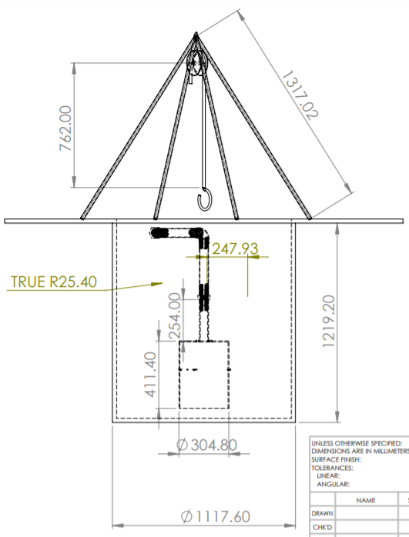
We use gas analysers have been selected because they are lightweight, portable devices, which measure the concentration of a gas in a known volume. We have incorporated this equipment into a flux chamber design, adapted from those previously used in septic tanks by Diaz-Valbuena et al., (2010) and Huynh et al., (2021). The flux chamber has been designed to incorporate both portable gas analysers, with input and output tubes connected simultaneously. Both analysers use air recirculation within the devices, negating the need for a fan that is used in other designs. This recirculation ensures that the gas is mixed well before taking readings, whilst also ensuring no negative pressure within the flux chamber. We use two chambers, with different diameters, 6 and 12 inches, allowing for a combination of maximum surface area to be covered, and lower time to fill the volume of the chamber, while also being able to fit inside the opening of septic tanks and pit latrines, which are much smaller.
Figure 2: blueprint of 12” flux chamber design with pully system (dimensions in mm).
When a measurement is to be taken, the flux chamber is attached to a tripod and pully system and lowered into the sanitation containment with the gas analysers attached. GHG emissions measurements are taken over the course of an hour, in addition using portable devices to measure flow rate and physiochemical parameters like temperature, pH, oxidation-reduction potential (ORP), total solids (TS), volatile solids (VS), and electrical conductivity (EC).
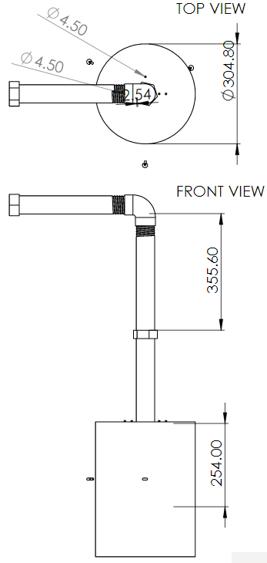
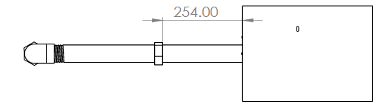
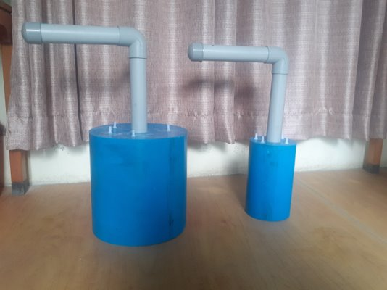
Onsite measurements will be combined with household surveys and site inspections to determine current design, operation, and maintenance criteria.
Figure 3: Top: blueprint of flux chamber design. Bottom: 12- and 6-inch flux chambers fabricated in Nepal.

EXPECTED OUTCOMES
Firstly, the emissions work from the SCARE project is expected to result in a consolidated and refined methodology and protocol for measuring GHG emissions from onsite sanitation systems. These can be used as a basis for a global study of emissions from onsite sanitation systems in a range of contexts including both HICs and LMICs. This can form the basis for our second outcome - a more accurate assessment of GHG emissions from onsite sanitation globally. This will lead to improved methodologies for assessing GHG emissions from onsite sanitation (e.g., IPCC methods), which in return will allow policy- and decision-makers to make better-informed decisions on present and future sanitation requirements, with the possibility of allowing access to climate financing.

GET IN TOUCH
If you want to get more information about the SCARE project and to access the tools and guidance as these become available please visit our website: http://www.bristol.ac.uk/engineering/research/water-and-sanitation/sanitation-and-climate/ or email Dr Anisha Nijhawan (anisha.nijhawan@bristol.ac.uk).

References:
- Dickin, S., Bayoumi, M., Giné, R., Andersson, K. and Jiménez, A. (2020). Sustainable sanitation and gaps in global climate policy and financing. npj Clean Water, 3(1).
https://doi.org/10.1038/s41545-020-0072-8
- Diaz-Valbuena, Libia R., Harold L. Leverenz, Christopher D. Cappa, George Tchobanoglous, William R. Horwath, and Jeannie L. Darby. 2011. “Methane, Carbon Dioxide, and Nitrous Oxide Emissions from Septic Tank Systems.” Environmental Science and Technology 45 (7): 2741–47.
- Huynh, Loi Tan, Hidenori Harada, Shigeo Fujii, Lien Pham Hong Nguyen, Thu Huong Thi Hoang, and Hai Trung Huynh. 2021. “Greenhouse Gas Emissions from Blackwater Septic Systems.” Environmental Science and Technology 55 (2): 1209–17.
- Progress on household drinking water, sanitation, and hygiene 2000-2020: five years into the SDGs. Geneva: World Health Organization (WHO) and the United Nations Children’s Fund (UNICEF), 2021. Licence: CC BY-NC-SA 3.0 IGO.
- Reid, Matthew C., Kaiyu Guan, Fabian Wagner, and Denise L. Mauzerall. 2014. “Global Methane Emissions from Pit Latrines.” Environmental Science and Technology 48 (15): 8727–34.
- Ryals, Rebecca, Gavin McNicol, Stephen Porder, and Sasha Kramer. 2019. “Greenhouse Gas Fluxes from Human Waste Management Pathways in Haiti.” Journal of Cleaner Production 226: 106–13.
- Huynh, L. T.; Harada, H.; Fujii, S.; Nguyen, L. P. H.; Hoang, T.-H. T.; Huynh, H. T., Greenhouse Gas Emissions from Blackwater Septic Systems. Environmental Science & Technology 2021, 55, (2), 1209-1217

